**“REFRIGERATOR DETAILS”**

In the refrigeration cycle, there are five basic components: fluid refrigerant; a compressor, which controls the flow of refrigerant; the condenser coils (on the outside of the fridge); the evaporator coils (on the inside of the fridge); and something called an expansion device.19-Sept-2012

[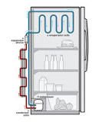](https://www.google.com/search?sxsrf=APq-WBvpOHp2rGOcuYg44QOCVNfNC7rmlA:1650485391055&q=What+are+the+5+parts+of+a+fridge?&tbm=isch&source=iu&ictx=1&vet=1&fir=7IAH36UNcOU_tM%2CWSoktKZmgOhaEM%2C_&usg=AI4_-kSDLM1hS2HvDceeIginmmix_6xNgQ&sa=X&ved=2ahUKEwi48cKbuaP3AhWZhf0HHcRXD88Q9QF6BAghEAE#imgrc=7IAH36UNcOU_tM)

What is refrigerator and its uses?

[[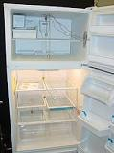](https://www.google.com/search?sxsrf=APq-WBvpOHp2rGOcuYg44QOCVNfNC7rmlA:1650485391055&q=What+is+refrigerator+and+its+uses?&tbm=isch&source=iu&ictx=1&vet=1&fir=uW7gqWh_yP74RM%2CBS1GXGt16O3B6M%2C_&usg=AI4_-kRf_zTbBRuSsiyR8FqXpa3YhwfEVw&sa=X&ved=2ahUKEwi48cKbuaP3AhWZhf0HHcRXD88Q9QF6BAggEAE#imgrc=uW7gqWh_yP74RM)](https://www.google.com/search?sxsrf=APq-WBvpOHp2rGOcuYg44QOCVNfNC7rmlA:1650485391055&q=What+is+refrigerator+and+its+uses?&tbm=isch&source=iu&ictx=1&vet=1&fir=uW7gqWh_yP74RM%252CBS1GXGt16O3B6M%252C_&usg=AI4_-kRf_zTbBRuSsiyR8FqXpa3YhwfEVw&sa=X&ved=2ahUKEwi48cKbuaP3AhWZhf0HHcRXD88Q9QF6BAggEAE" \l "imgrc=uW7gqWh_yP74RM)

A refrigerator is **a machine used for keeping things cold**. It is sometimes called a fridge or an icebox. It is normally maintained at 4-5 degree Celsius for household use. People put food and drinks in it, to keep those items cold or good (unspoiled) for a longer time.

**Smart Refrigerator**

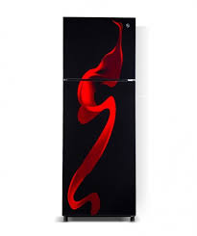

HRF-758S

VISIBLE FOOD MANAGNMENT  
CONVERTABLE ZONE  
TRIPLE ZONE SYSTEM

PKR 89,990.00